Cheng Huang Temple (對話改寫創作!!)
Cast(卡司): Mark: AE1-2 No. 20 Zoe Ken: AE1-2 No. 15 Sara
(A foreign tourist named Mark, who wanted to visit Cheng Huang Temple,
lost his way, trying to ask a local student named Ken for directions.)
Mark: Excuse me, could you tell me how to go to Cheng Huang Temple?
Ken: I beg your pardon?
Mark: I want to visit Cheng Huang Temple. Would you please show me the way?
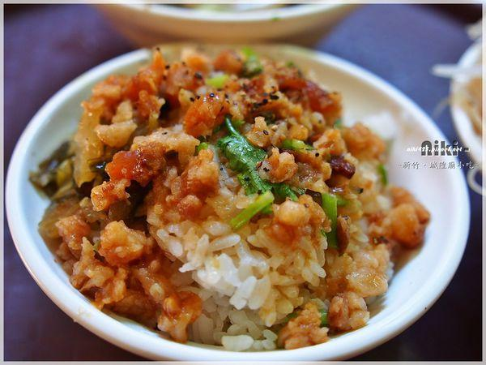
Ken: Oh, I see. I can take you there because I want to go to Liu’s Braised Pork Rice to buy my lunch. It’s quite near Cheng Huang Temple.
(They walked across the East Gate and headed for Dongmen Street.)
Mark: Thanks. But what’s braised pork rice?
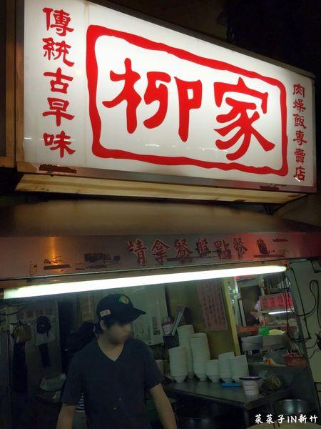
Ken: It’s the most famous braised pork rice in Hsinchu. The shop is inside the Cheng Huang Temple, and it offers the service to take out! It is always full of people at dinner time. The store sells many different kinds of Chinese food, such as stewed Chinese cabbage, meatball soup, and it’s very cheap!!! You should try some!
Mark: Wow, that sounds fascinating and my mouth is watering. Besides eating delicious food, what else is a must-do in this area?
Ken: You may burn some incense in the temple,
praying to the City God to protect you. It is said that it really works. Also, you can take a closer look at the sculptures and art designs on the wall or the ceiling. They are exquisite and ancient. Above all, pay more attention to the two lions at the entrance of the temple. (The temple is in sight.) Oh, here we are. This is Cheng Huang Temple.
Mark: (Excited and grateful) It’s quite near the train station. There are so many food stalls. It seems that I don’t need to worry about what to eat here. By the way, can you tell me more about the history of Cheng Huang Temple?
Ken: Of course. Cheng Huang Temple, founded in 1748, is also known as “City God Temple”. It’s said that Cheng Huang Temple was honored as “Wei-Ling Kung” by Emperor Guangxu of Qing Dynasty.
Mark: Thanks for your help and your wonderful guided tour! Bye!
*Make up your own dialogue by replacing the underlined sentences with new ones!

英一竹塹英語導覽課
第一次月考對話表演: (pairwork)
時間: 3/31(二) 1,2節 地點:英一2教室
*線上劇本完稿日: 3/24--3/29
(在表演日前未完成打字版劇本者，則月考成績扣10%)
Dialogue script: 20% Dialogue Performance: 80%
Body language, facial expression, fluency, volume of your voice,
pronunciation, attitude
Google classroom 學生帳號: s+學號@gm.hccvs.hc.edu.tw
Google classroom 學生密碼: hccvs+學號
每組請加老師共同協作我才能評分及修改:annwu@gm.hccvs.hc.edu.tw
If you work hard and are well-prepared, you’ll get good grades!!

